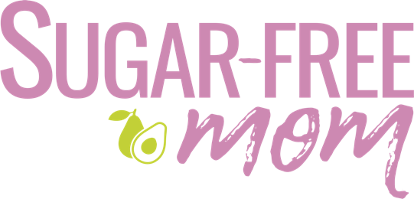
Before You Start

Brenda Bennett:
Hello and welcome to the Sugar Free Fresh Start Course. Before you start all the materials and modules, I just wanted to give you a few things to get going before you actually begin your module 1.
So the first thing is you are going to a whole food programme where you are not incorporating any kind of packaged processed foods. So for those of you who may be on medications, please seek your doctor's advice when it comes to reducing carbohydrates in your diet. Especially if you are diabetic, please check with them first and just do a visit and get your blood testing done prior to starting this course. Many of my clients and members who have taken this course over the years have seen considerable wonderful changes in overall health. So get your cholesterol checked, get all the markers checked so that you have some evidence of what has worked for you in this programme.
All right, next. Besides seeing your doctor or going for a visit to do your test markers, it's important to have a few things on hand and some things to remove. So the first few things I would recommend to get prior to starting is a food scale. A food scale is helpful to weigh and measure your protein. You'll notice in module 1 there is a lesson on prioritising protein. So it's really important to weigh your food because eyeballing it is really hard to do and prioritising protein is key. So I will leave a link below for a proper food scale.
The other thing is having a regular scale that you can weigh yourself on once a week or once a month is important. But that's not the only tool of measurement that you want. Measuring tape, a fabric measuring tape is really important because you want to know that if the number on the scale doesn't look as good as you had hoped, that you have another tool of measurement. And fat loss is really evident when you use a measuring tape. The number on the scale really can't show that. So a fabric measuring tape is important, as well as just wearing a pair of jeans every week to do a measurement tool like that. You'll see the scale, module 2, the scale lesson talks more about some other measurement tools besides the scale.
The other thing I would encourage you to do is clean out your cupboards because it's a fragile time when you are removing sugar and refined and packaged products. So at this time, you don't want to have them visible because it may tempt you. And so you want to reduce the options to eat those things, especially in times of stress, especially if you're an emotional eater. So my recommendation, if you have family in the house that are not following along, just ask them to move their things away from your eyesight and in a different part of the house, like in a different pantry or a different shelf or in a different cupboard so that you are not tempted to see them every day and feel the thoughts that you feel about when you're taking things away.
The other things that you can do are simply to ask for support from your family and friends. See if they want to join you, even if they don't. I did sugar-free since 2006, and my husband didn't get on board until 2018 and he brought all the things in. Just because people bring in doesn't mean they don't support you. They've just chosen that they don't want to do it too, and that is their prerogative, right? But it doesn't mean you have to eat it, and it doesn't mean that you have to feel bad that they are trying to tempt you. That is not the case at all. You have to just learn that it doesn't have to go in your mouth just because it's in the house. So beware of that.
Okay. The last thing that I really want you to do is take before and after photos. Before photos, before you get started. Why? Because at the end, I've had this time, and again, I had someone lose, I think it was 60 lbs and did not do before photos and regretted it at the end. Many of my clients did not do before photos. I encourage everyone to please do before photos because in a month or six weeks or two months, whatever it is, you are going to want to look back and see how well that you have really changed your habits and your behaviours and you're going to be so happy to have that evidence. So please take before photos.
And that's it my friends. Those are just a few things to just get started and have on hand before you start Module 1. The other thing too, I forgot to mention, is when you are cleaning out your pantry, to remove some of the things that are having labels with sugar in them. And you'll read in module 1 the lesson on reading labels for sugar. So I'm thinking condiments and salad dressings. I will put the link below to Primal Kitchen on Amazon. You can also find them at Target and at Walmart. But Primal Kitchen doesn't have sugar included in any of the condiments. And in their salad dressings, they use avocado oil. So those would be the things that I would recommend. You do want to have some things on hand for your whole food meals like mayo that doesn't use horrible seed oils and things like that so that you can make your food more without causing sugar cravings for you. All right, that's it. I'll see you in module 1.

