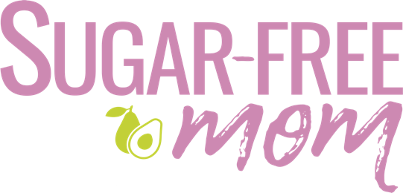
Welcome Video
Brenda Bennett: Hello and welcome to the Sugar-Free Fresh Start Course. My name is Brenda Bennett. I'm the blogger behind sugar-freemom.com. That's where all my free recipes are. And I'm also a nutritional therapy practitioner, a keto coach, a sugar detox coach. I wrote my first sugar detox course back in 2012.
I'm also a former sugar addict. And I dealt with sugar cravings and refined carb cravings for nearly 20 years, and then finally decided I wanted to end that cycle. I was sick of yo-yo dieting. I was sick of being controlled by this craving for sugar and refined carbs. I was sick and tired of feeling like I had no control. And in 2006, I decided that sugar and refined carbs were no longer an option for me. And I stopped giving in to the constant pull to eat for comfort and emotionally eat for many emotions that I had.
And so in 2012, I decided, after many years of doing this on my own, that I wanted to help others, not only through my free recipes that are sugar-free and low carb and keto, but through coaching. And so I became a nutritional therapy practitioner to learn the nutrition behind it all. I became a keto coach to help more people in that area.
But my new course is really an updated version of my six-week course that I wrote back in 2012, and then I revamped it in 2020. And now, currently, I decided that I didn't want to have it be six weeks because I wanted it to be more about you, the person who decides, "You know what? I want to dive into this information more quickly" than the six-week course that I had. So I created this Fresh Start Course to be in modules so that you can take as long or as little as you like and personalise the course for you.
I don't tell you that you have to do keto, but I do give you guidelines. And you'll learn that in module one. The basics, the foundation of what I teach on and what I coach on in my Tribe membership is something that you'll learn in module one, of how to balance the blood sugar to reduce the physical cravings. And then in module two, you'll learn about how to deal with the emotional cravings because there's two sides to every coin, right? And it's not just about what you're eating, it's about what's eating you. And that's why you've turned to old habits in the past. So if you're new here, and this is your first experience with my coaching, my hope is that you will learn the tips, the tricks, the ways to feed yourself so that you will feel great, you will lose the weight you want to lose, and you'll end those sugar cravings so that you can learn how to sustain this long-term.
And if you're here too, if you don't have to lose weight, but sugar just calls your name, you are welcome to dive into this course as well. And you'll just work on maintenance calories so that you don't lose weight. But you will learn how to balance your blood sugar, so that those cravings don't continue to control you.
I welcome you all. Thank you for having courage to try again. And I promise you, if you stick with this and really commit to the programme, you will see weight loss, cravings eliminated, and you will learn how to manage your mind, so that the cravings to turn back to old habits for comfort will end. And you will learn all the ways to make this lifestyle sustainable for you. All right, let's dive in.

