

**Sugar-Free FRESH START Course**

**Body Measurement Progress Tracker**

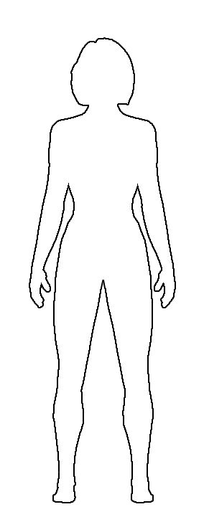

**1 CHEST**

Week 1: _________

Week 2: _________

Week 3: _________

Week 4: _________

Week 5: _________

Week 6: _________

**2 ARMS**

Week 1: _________

Week 2: _________

Week 3: _________

Week 4: _________

Week 5: _________

Week 6: _________

**3 WAIST**

Week 1: _________

Week 2: _________

Week 3: _________

Week 4: _________

Week 5: _________

Week 6: _________

**4 HIPS**

Week 1: _________

Week 2: _________

Week 3: _________

Week 4: _________

Week 5: _________

Week 6: _________

**5 THIGHS**

Week 1: _________

Week 2: _________

Week 3: _________

Week 4: _________

Week 5: _________

Week 6: _________

1

2

3

4

5

**Name: ________________________   
Age: _____ Height: __________  
Body Fat %: ______  
Activity Level: (0=none <> 10=very)  
  
 0 5 10**

|  |  |  |  |  |  |  |  |
| --- | --- | --- | --- | --- | --- | --- | --- |
| PROGRESS TRACKER | START  Date: | WEEK 1  Date: | Week 2  Date: | Week 3  Date: | Week 4  Date: | Week 5  Date: | Week 6  Date: |
|  |  |  |  |  |  |  |  |
| Weight |  |  |  |  |  |  |  |
| 1 Chest |  |  |  |  |  |  |  |
| 2 Arms |  |  |  |  |  |  |  |
| 3 Waist |  |  |  |  |  |  |  |
| 4 Hips |  |  |  |  |  |  |  |
| 5 Thighs |  |  |  |  |  |  |  |